**DIMIK INFOTECH LIMITED**

This is a IPO Application process where a user can apply for IPO of different types of companies. A user can apply one IPO per company/fund. Follow the bellow process for implementing this IPO Application process,

* You have to create a simple login process using Identity Server.
* 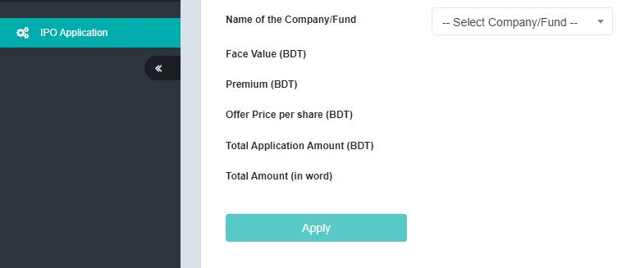After successfully signing you have to show the dashboard of the user. In the menu bar (navbar or left side menu bar) you have to create a hyperlink. Named this hyperlink "IPO Application". When clicked this hyperlink redirect to the IPO Application form. The IPO Application form should be looked like this,
* You have to load Company/Fund dynamically in a dropdown from the IPO Information table in database. Load those companies whose start date and end date belong to current DateTime.

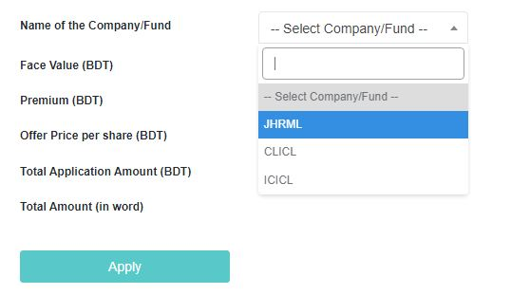

* Now selecting a Company/Fund you have to show the selecting Company/Fund details from IPO Information table in database. After selecting a Company/Fund the form should be looked like this,

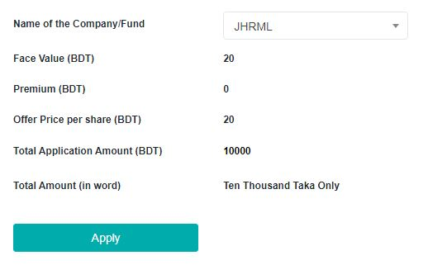

* When clicking on the apply button store the information in the IPO Application table in the database.

**NOTE :**

* You do not need to create a curd operation for the IPO Information Table. Just follow the bellow section, create and insert the IPO Information table and data manually.
* One user can apply only one times per Company/Fund

**TABLE SCHEMA :**

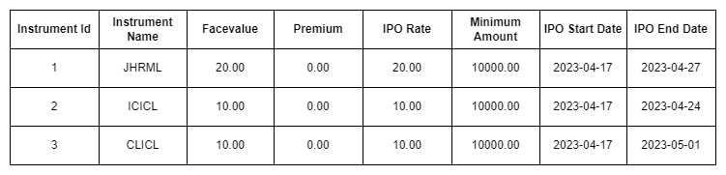IPO INFORMATION

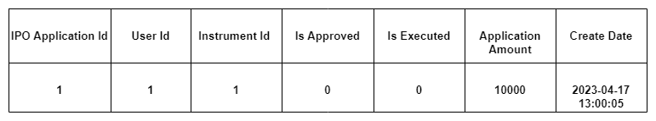IPO APPLICATION